CLOUD COMPUTING LAB: WEEK 4

PES1201802127

Siddharth K Rao

1. Understand publisher subscriber pattern through application-to-person (A2P) messaging.

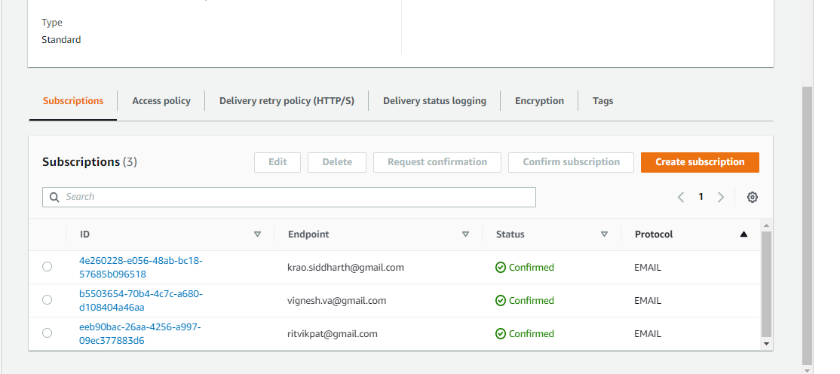

(4a) All Subscriptions

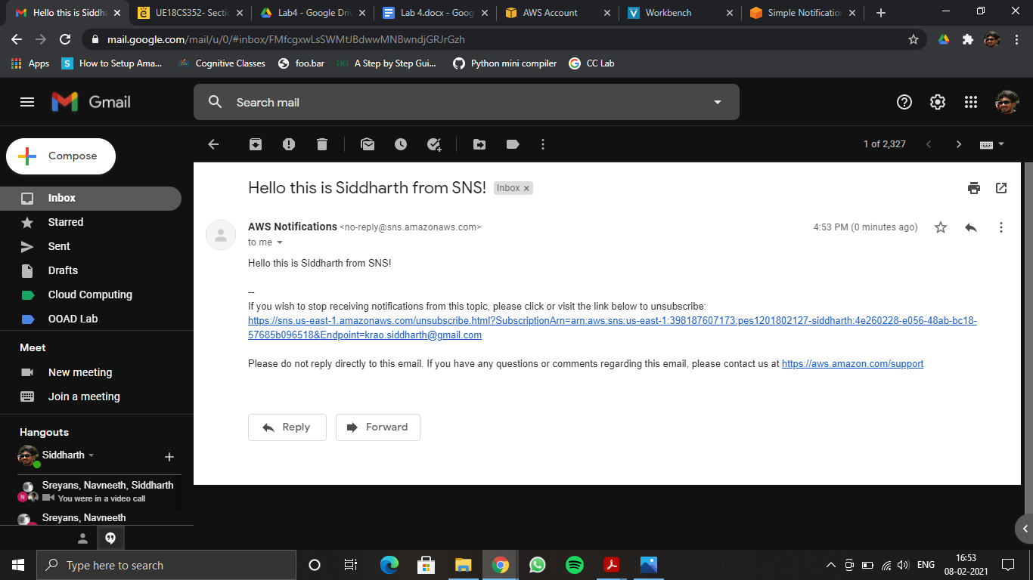

(4b)

1. Play around with SQS queues.

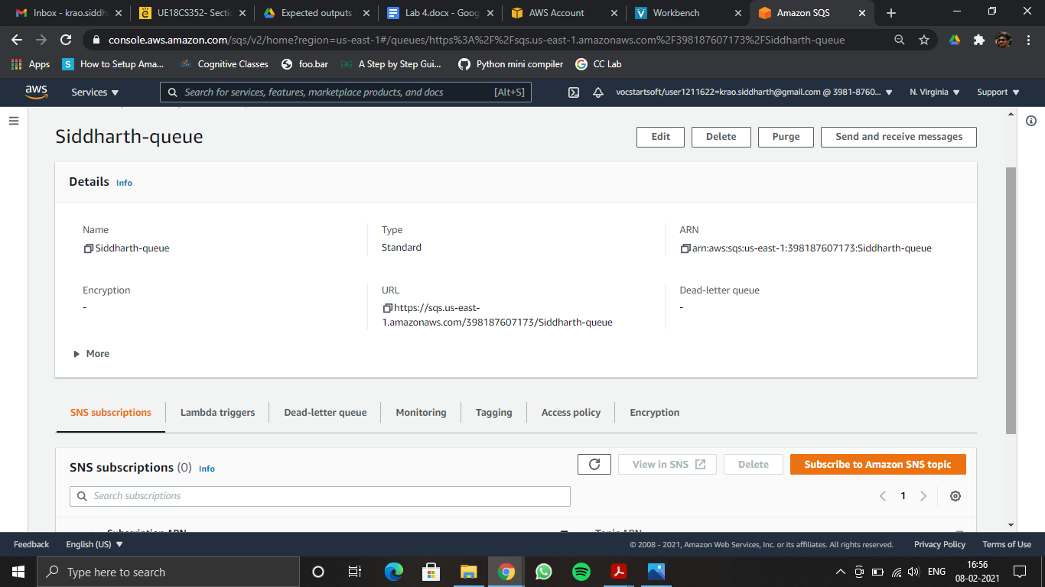

(4c)

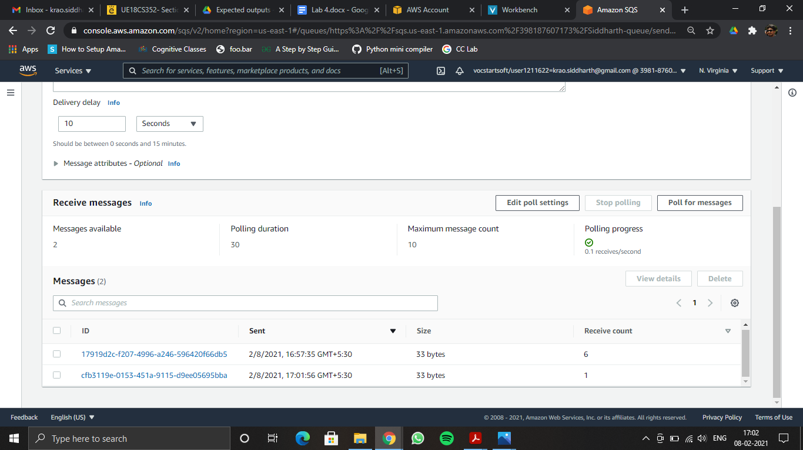

(4d)

1. Using Amazon SNS and Amazon SQS together.

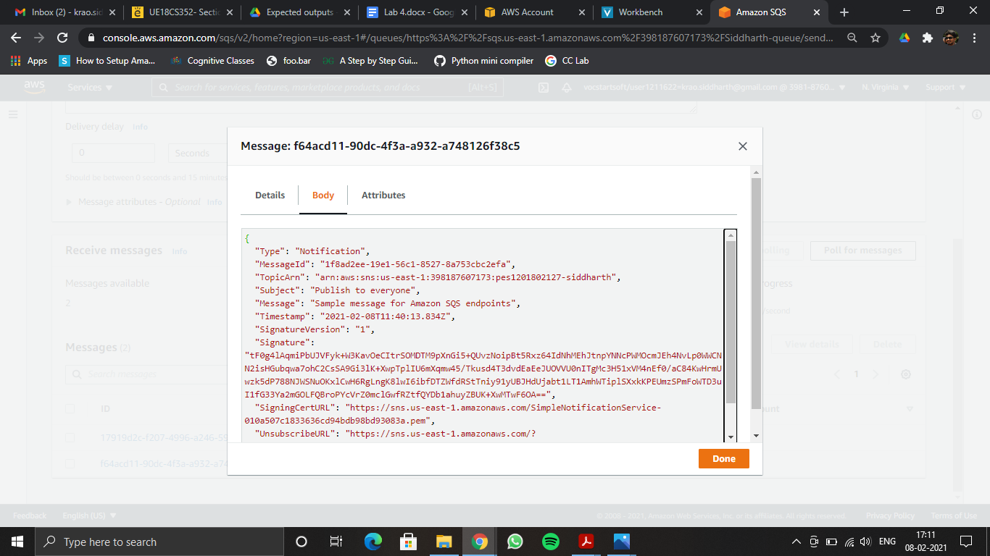

(4e)